Import Data using Transform Maps (Spreadsheet)
A Project Report Submitted in Partial Fulfillment of the Requirement for the Award of the Degree in
BACHELOR OF COMPUTER APPLICATIONS

Submitted By

Geetharani .S - 24081040500112104

Praveena .M - 24081040500112111

Muthulatha.M - 24081040500112108

Arunadevi . A - 24081040500112103



DECLARATION
I hereby declare that the project titled “Import Data using Transform Maps (Spreadsheet)” is an original work carried out by me as part of my academic project. This project focuses on importing spreadsheet data into ServiceNow using Import Sets and Transform Maps, with the aim of reducing manual data entry and ensuring that records are transferred accurately into the required target table.
I further declare that the information, implementation, and results presented in this project are based on my own work and understanding, and that this project has not been submitted previously to any other institution for the award of any degree or certification.

The project “Import Data using Transform Maps (Spreadsheet)” focuses on importing structured spreadsheet data into ServiceNow in an organized and automated manner. In a manual process, entering a large number of records individually can take more time and may result in data entry errors.
This project uses the ServiceNow Import Set and Transform Map mechanism to load spreadsheet data into a staging area and transform it into records in a target table. The required source fields are mapped to the corresponding target fields, allowing data to be transferred in a consistent manner.
The main purpose of this project is to reduce manual data entry, improve data accuracy, simplify bulk record creation, and demonstrate a structured data import process. The final output demonstrates that spreadsheet records can be imported, transformed, and stored successfully in the selected ServiceNow target table.

S. No. | Phase | Page No.
1 | Brainstorming & Ideation Phase | 1
2 | Requirement Analysis Phase | 3
3 | Project Design Phase | 4
4 | Project Planning Phase | 6
5 | Project Development Phase | 8
6 | Project Testing Phase | 10
7 | Project Documentation Phase | 11
8 | Project Demonstration Phase | 13
9 | Conclusion | 14

To identify a practical data-import problem and propose a structured solution using ServiceNow Import Sets and Transform Maps.

Activities Performed
- The project idea was developed around importing records maintained in a spreadsheet into ServiceNow.
- Common issues considered were repeated manual data entry, inconsistent field values, import errors, and time required for bulk record creation.
- The team identified Import Sets and Transform Maps as suitable ServiceNow features for handling spreadsheet-based data imports.
- The proposed solution focuses on transforming source spreadsheet fields into the corresponding fields of a ServiceNow target table.

Expected / Produced Output
The project concept: when a spreadsheet containing valid source records is uploaded, the data is loaded into an import set and transformed into records in the selected target table.

Screenshots:

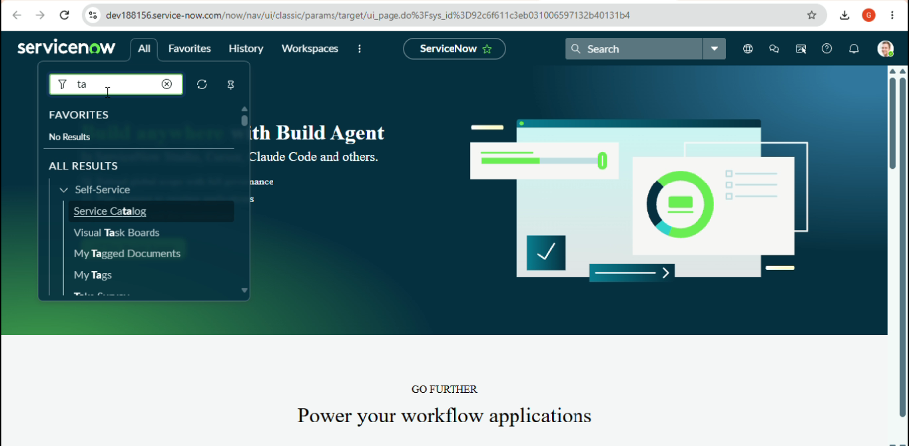

To understand the source data, target table, fields, transformation requirements, validation needs, and expected outcome of the spreadsheet import process.

Activities Performed
- Identify the spreadsheet containing the source records.
- Define the columns and values available in the spreadsheet.
- Identify the ServiceNow target table where the records should be stored.
- Determine the source-to-target field mappings required for the import.
- Define any transformation or data-cleaning requirements.
- Identify validation and error-handling requirements for imported records.

Expected / Produced Output
The requirement analysis results in a clear data-import workflow: Spreadsheet Preparation → Import Set
→ Transform Map → Field Mapping/Transformation → Target Table → Imported Records.

Screenshots:

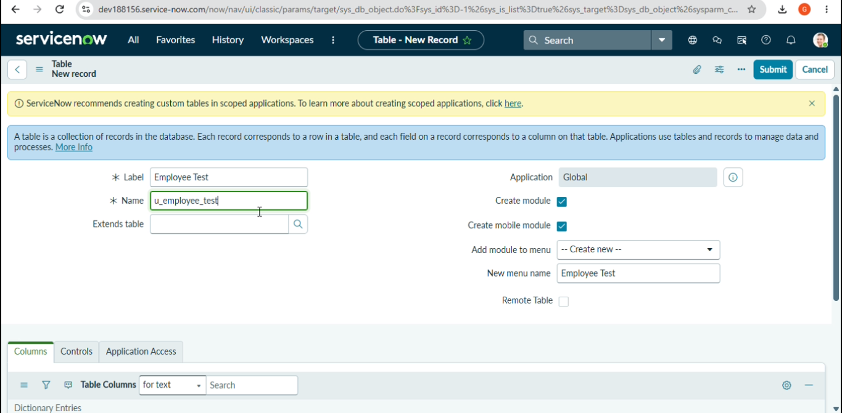
To design the logical data-import structure before implementing it in ServiceNow.

Activities Performed
- Design the source spreadsheet structure and required columns.
- Define the import set process for loading spreadsheet data.
- Design the Transform Map connecting the import set to the target table.
- Map source fields to their corresponding target fields.
- Plan any required field transformations or data validation.
- Plan verification of imported records in the target table.

Expected / Produced Output
High-level data-import design: Spreadsheet → Import Set → Transform Map → Field Mapping/Transformation → Target Table → Verification.

Screenshots:

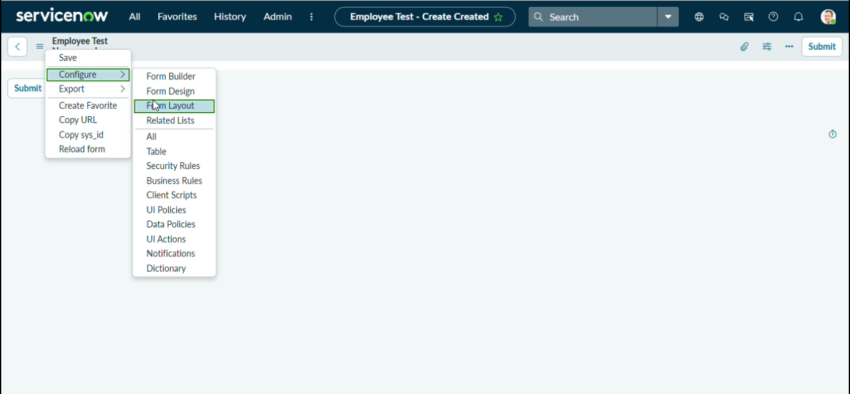
To organize the implementation into manageable activities and define the sequence of work.

Activities Performed
- Review the project objective and finalize the scope.
- Prepare the required ServiceNow application, target table, spreadsheet, users, and test data.
- Prepare the spreadsheet with sample records and required fields.
- Create the Import Set and configure the Transform Map.
- Configure source-to-target field mappings and required transformations.
- Prepare positive and negative test scenarios.
- Capture screenshots and prepare the final project documentation.
- Prepare the demonstration sequence for explaining the completed import process.

Expected / Produced Output
The planned implementation follows a structured sequence from environment preparation to development, testing, documentation, and demonstration.

Screenshots:

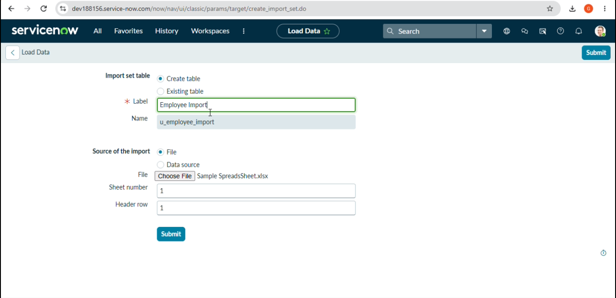
To implement the spreadsheet data import using ServiceNow Import Sets and Transform Maps.

Activities Performed
- Prepare the spreadsheet with the required source data.
- Open the ServiceNow import functionality and load the spreadsheet.
- Create or select the required Import Set and staging structure.
- Create the Transform Map for the selected target table.
- Configure the source and target field mappings.
- Add required transformation logic or data handling rules.
- Run the transform process.
- Verify that the records are created or updated correctly in the target table.
- Save, validate, and complete the configured import process.

Expected / Produced Output
A working ServiceNow spreadsheet import process using Import Sets and Transform Maps.

Screenshots:
Insert relevant ServiceNow screenshots for this phase.

To verify that the spreadsheet import and transformation process behaves correctly for different source data conditions.

Activities Performed
- Test a valid spreadsheet containing correctly formatted records.
- Verify that the spreadsheet data is loaded into the Import Set.
- Verify that the Transform Map is triggered and processed correctly.
- Check that source fields are mapped to the correct target fields.
- Verify that imported records appear correctly in the target table.
- Test records containing missing, invalid, or inconsistent values where applicable.
- Check transformation results and identify any rejected or erroneous records.
- Correct configuration issues and repeat the test before final demonstration.

Expected / Produced Output
The import process should transfer valid records into the target table without errors, while invalid or non-applicable data should be identified and handled according to the configured transformation rules.

Screenshots:

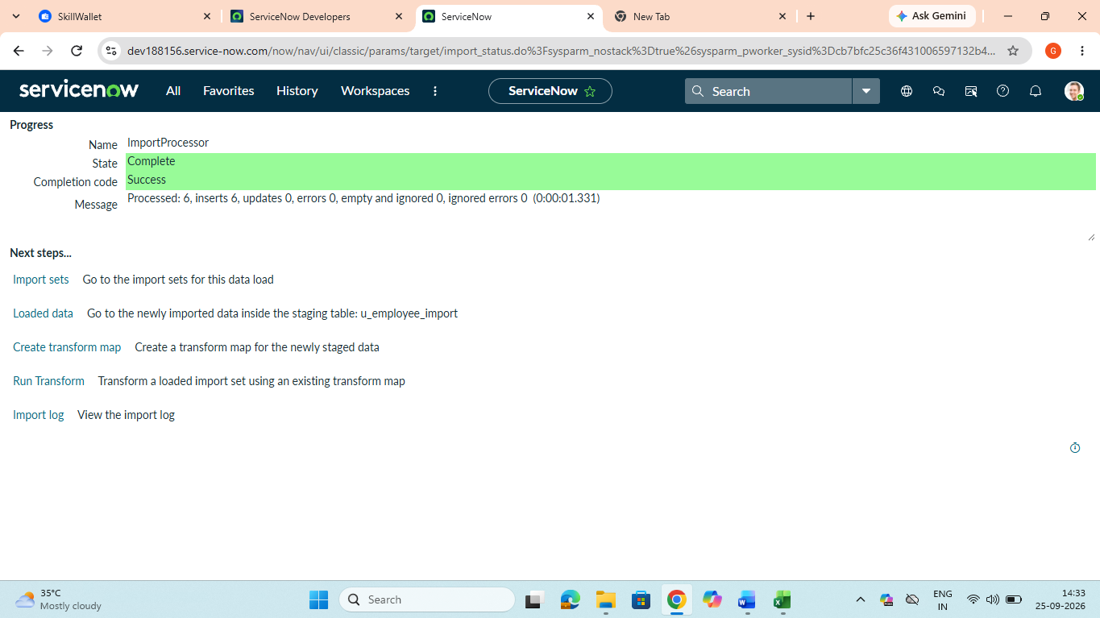

To record the complete project process, configuration, testing evidence, and final outcome in a clear and reusable format.

Activities Performed
- Document the project title, objective, scope, and problem statement.
- Document each project phase from ideation through demonstration.
- Describe the source spreadsheet and target table requirements.
- Document the Import Set, Transform Map, and field-mapping configuration.
- Include screenshots as evidence for configuration and execution.
- Document test scenarios and observed results.
- Record the final outcome, limitations, and possible future enhancements.

Expected / Produced Output
This document provides the phase-wise record of the project and can be used as the final project documentation.

Screenshots:

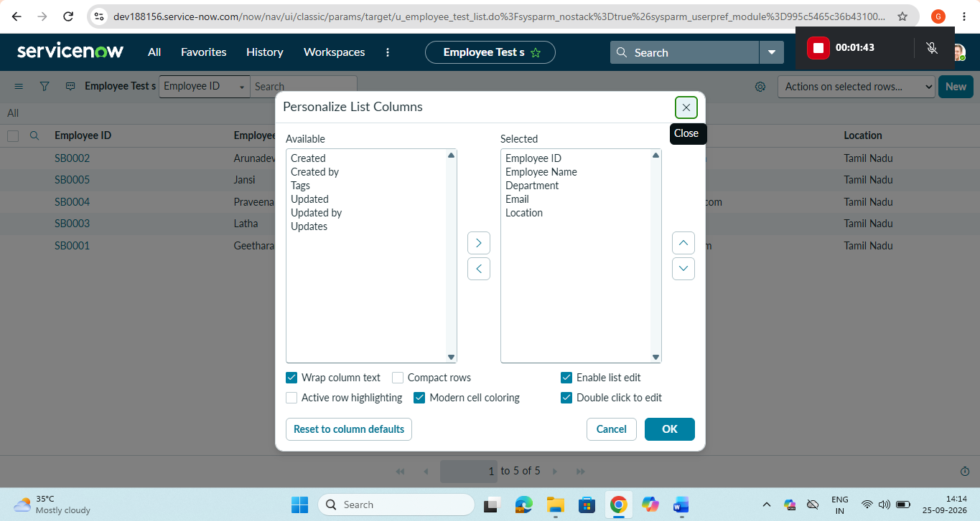

To demonstrate the completed spreadsheet import process and explain how Transform Maps reduce manual data entry.

Activities Performed
- Introduce the project problem and objective.
- Show the prepared spreadsheet and explain its fields.
- Demonstrate the spreadsheet import into ServiceNow.
- Show the Import Set and imported source records.
- Show the configured Transform Map.
- Demonstrate the source-to-target field mappings.
- Run the transform process.
- Show the resulting records in the target table.
- Show the import/transform execution details and test evidence.
- Summarize the benefits and possible future enhancements.

Expected / Produced Output
The demonstration should show a complete end-to-end data-import lifecycle from spreadsheet preparation to final records in the target table.

Screenshots: 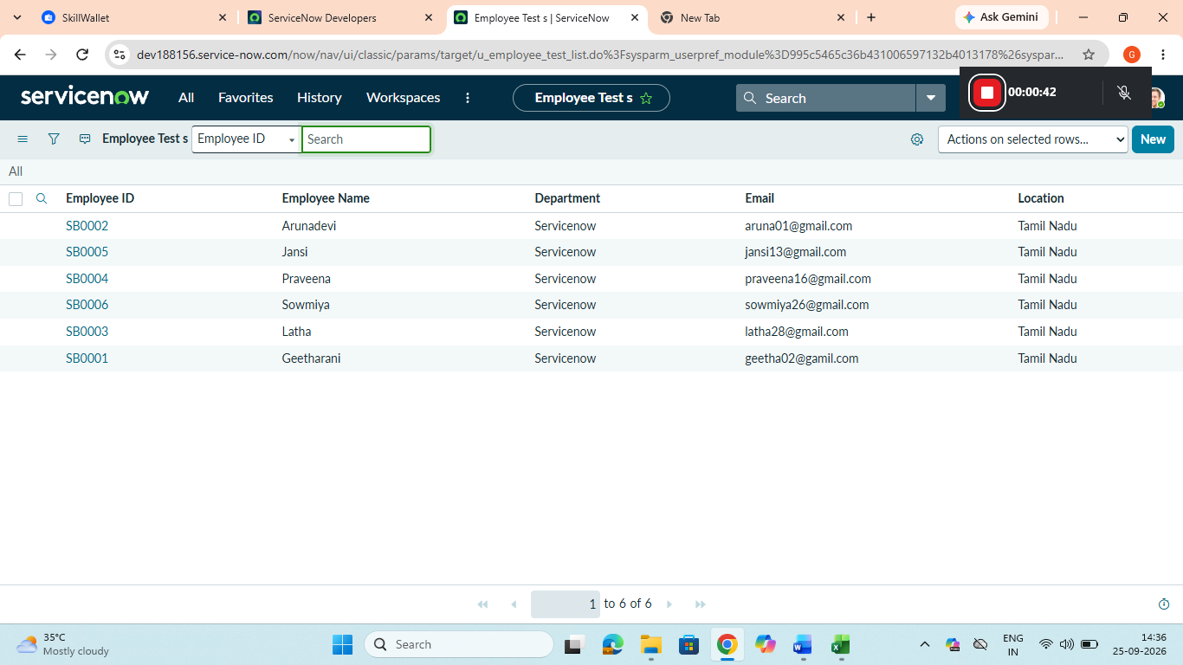

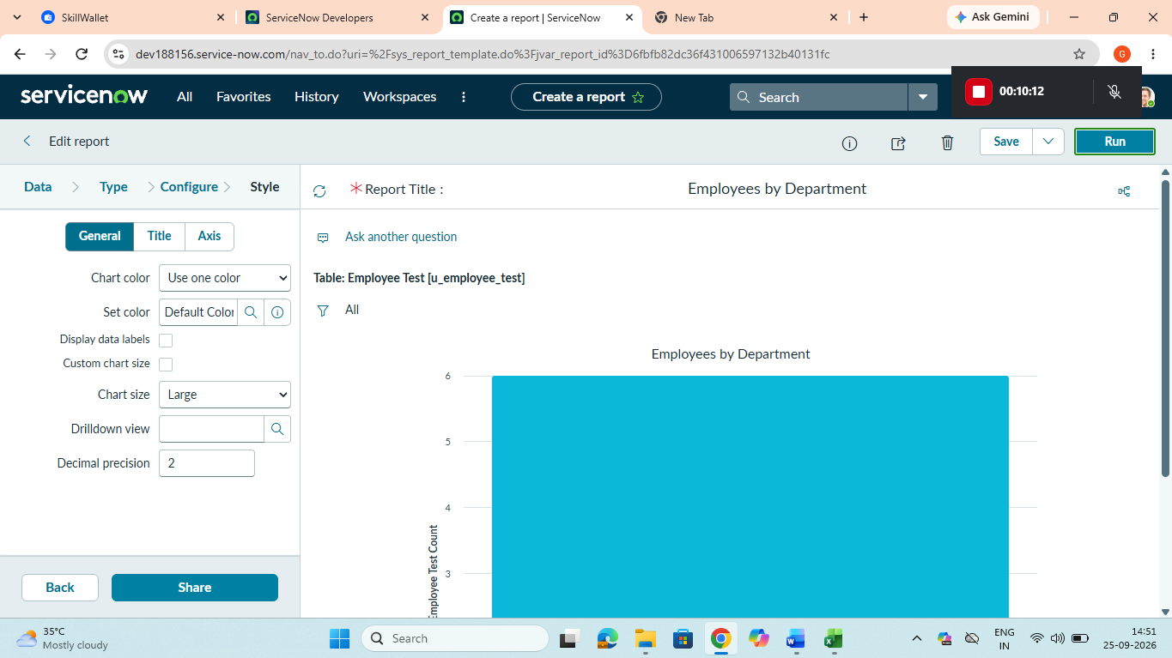
.
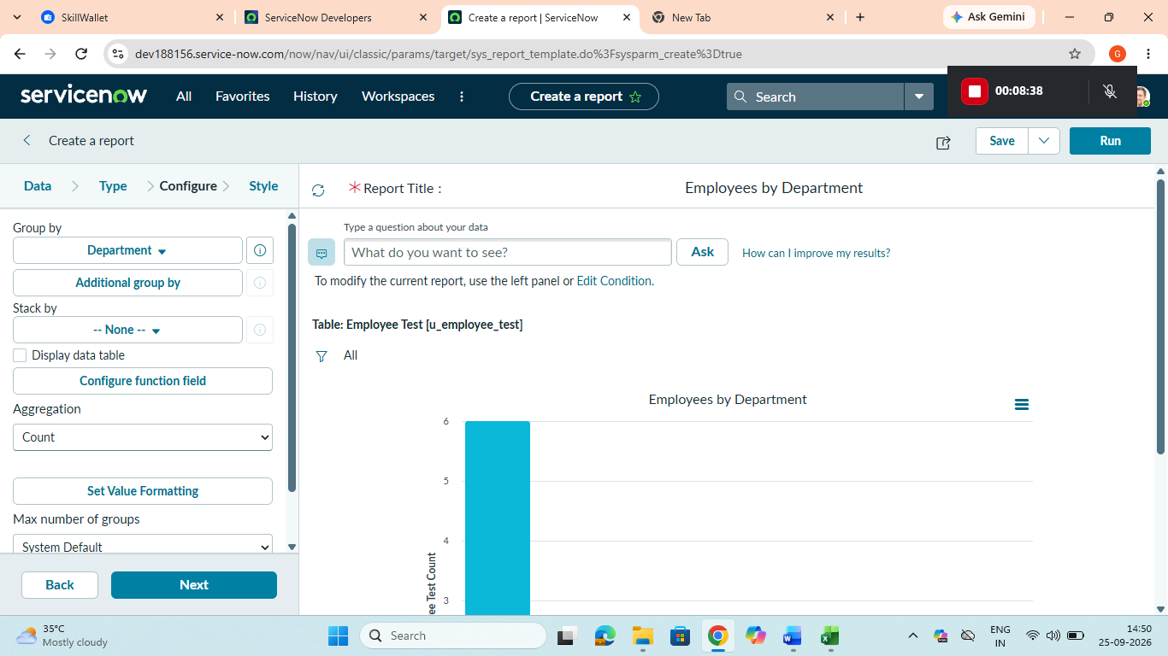

Conclusion
The project demonstrates how ServiceNow Import Sets and Transform Maps can be used to import spreadsheet data into a target table in a structured manner. By mapping source fields to target fields and applying required transformation rules, the process can reduce manual data entry and provide a consistent approach to bulk record creation.
The phase-wise approach covers idea generation, requirement analysis, design, planning, development, testing, documentation, and demonstration. The same import and transformation approach can be extended to other datasets and ServiceNow tables in the future.

Future Enhancements
  - Add advanced data validation before transformation.
  - Add data cleansing and standardization rules for inconsistent spreadsheet values.
  - Use coalesce or matching rules where appropriate to identify existing records.
  - Add error reporting and monitoring for failed or rejected records.
  - Schedule recurring imports for regularly updated spreadsheet data.
  - Extend the process to multiple target tables and larger datasets.
  - Provide dashboards or reports to monitor import and transformation results.
  - Add notifications for successful imports and import errors.

